**--Everytime that I use Template Deployment, if some resource fails to be created, I have to manually delete all the resources. This is not good.**

**--Always that any resource fails to be deployed, the entire template needs to be rolled back.**

**Arm Template Deployment modes**

Arm template for service bus namespace, topic and subscription created in incremental mode

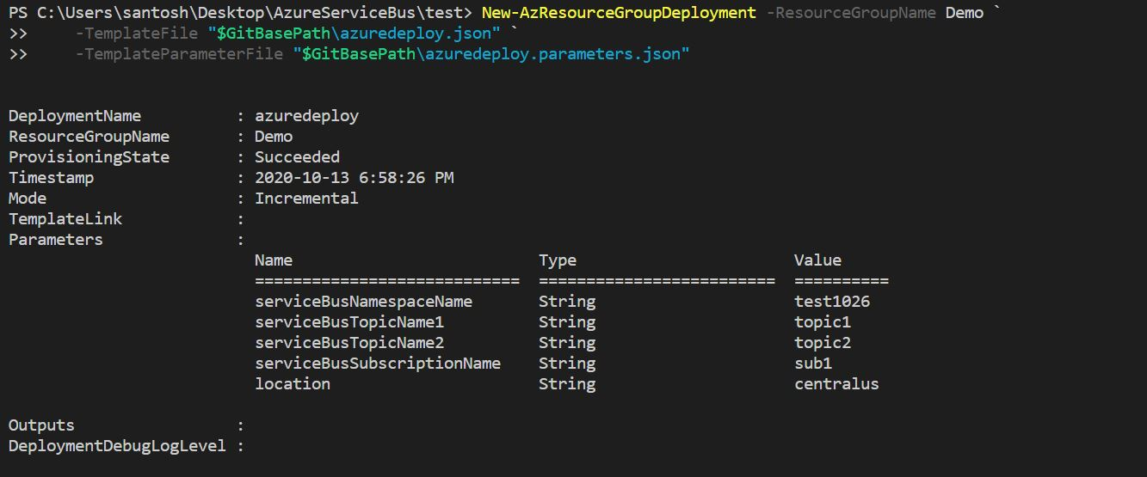

Same template deployed with different topic name but deployed in incremental mode, so another topic added to the namespace

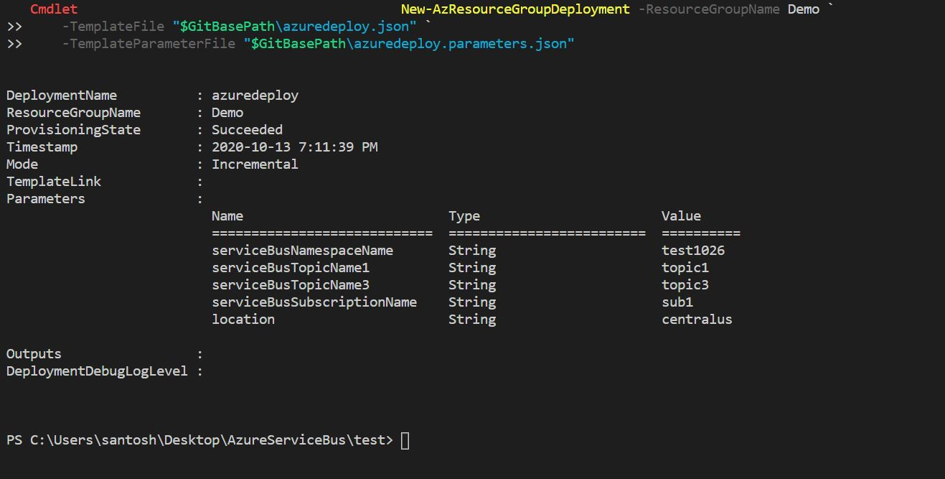

Deployed the same template in different Resource group with Complete mode

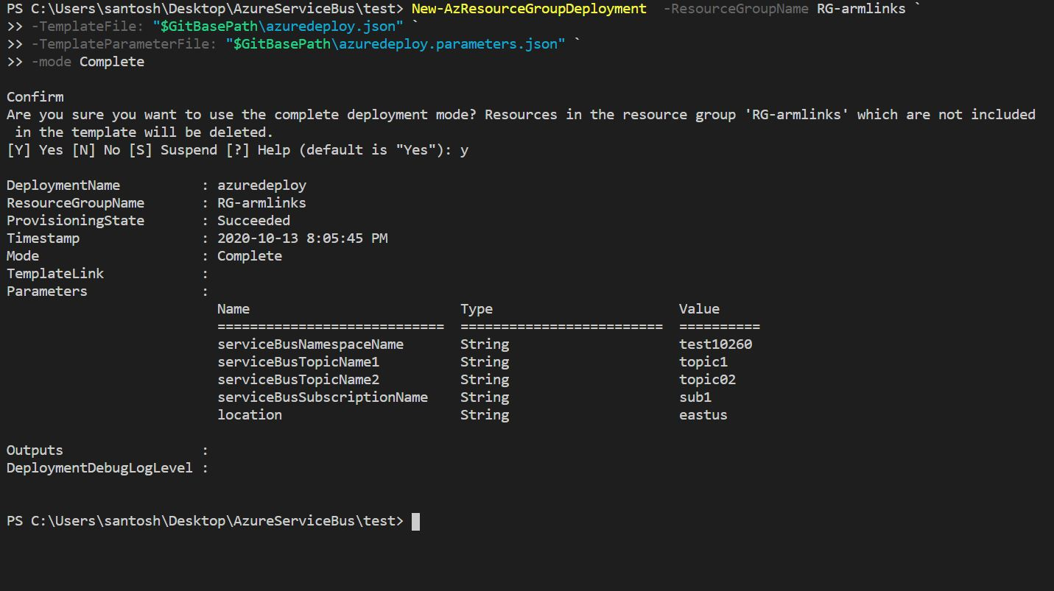

Did a Roll back to previous deployment “test02” with default Incremental mode

so resources present in the template added to the resource group

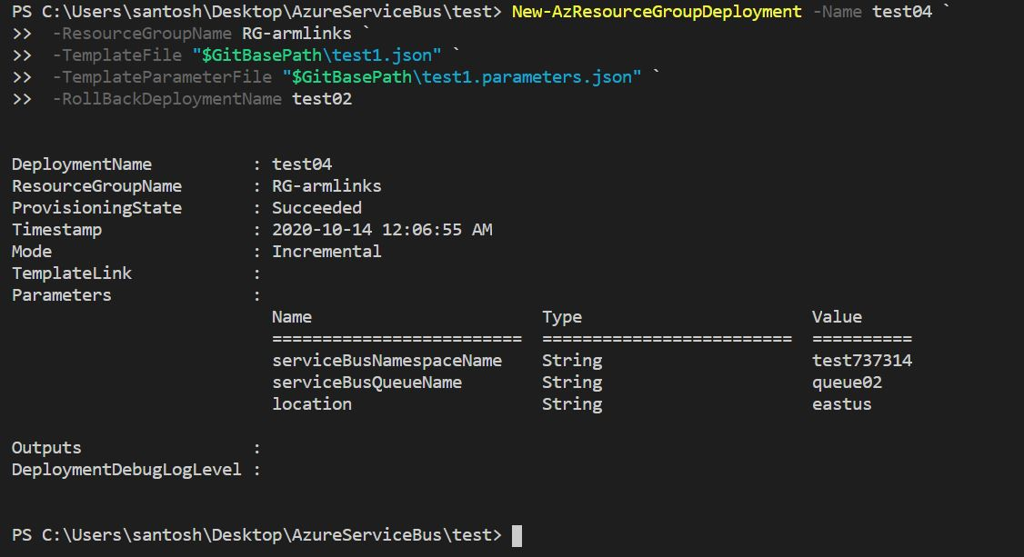

Roll back to previous deployment “test02” with Complete mode

The observations are other resources got deleted but queues still exist in the namespace and current template queue added to the namespace

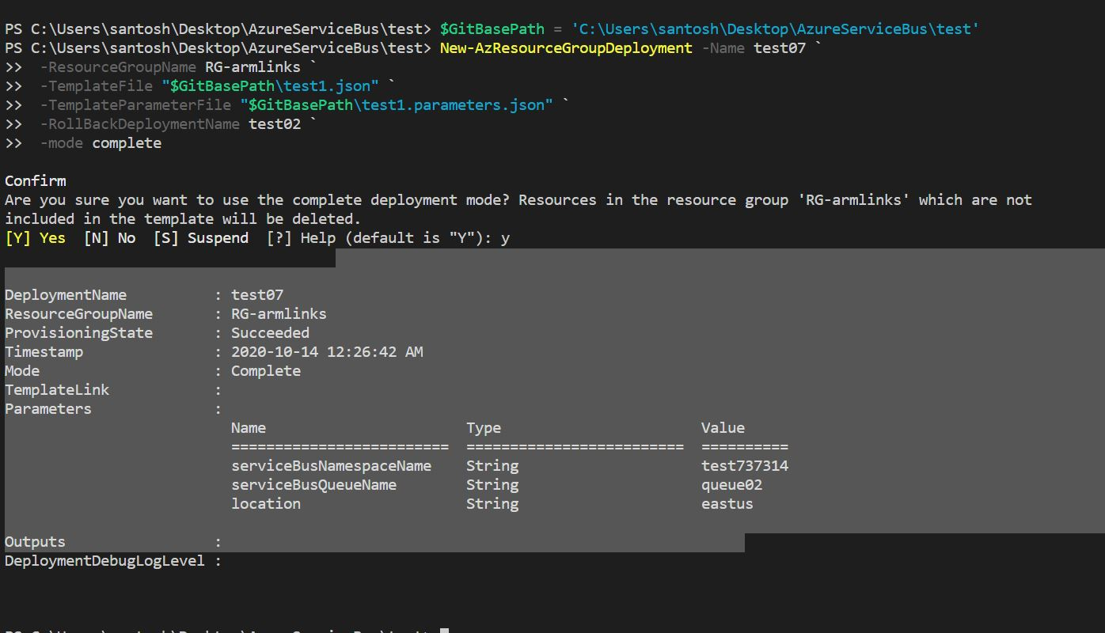

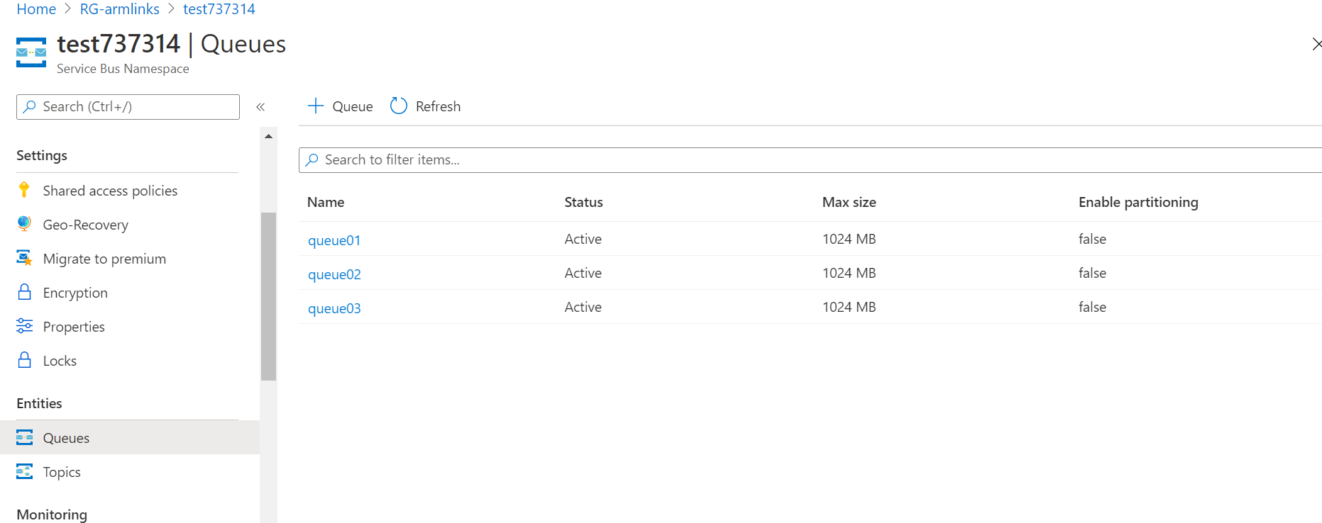

Creating a Azure service bus Namespace with incremental mode:

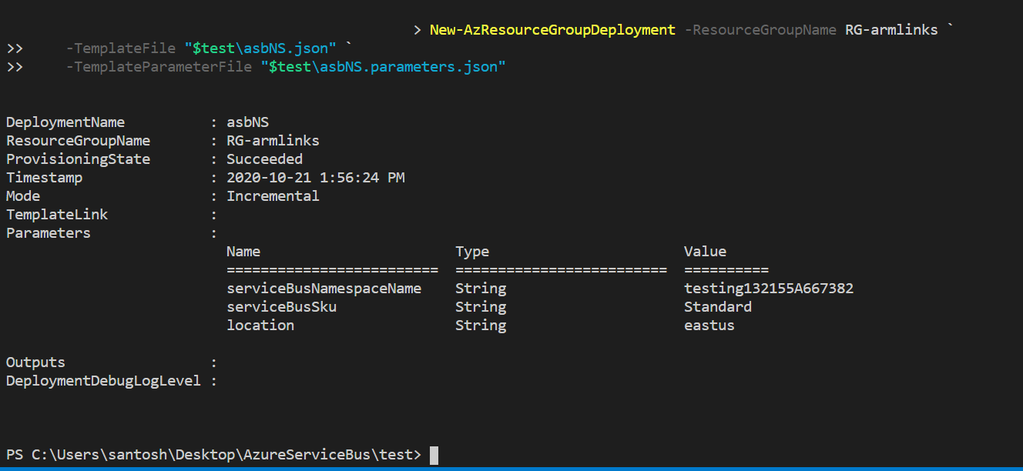

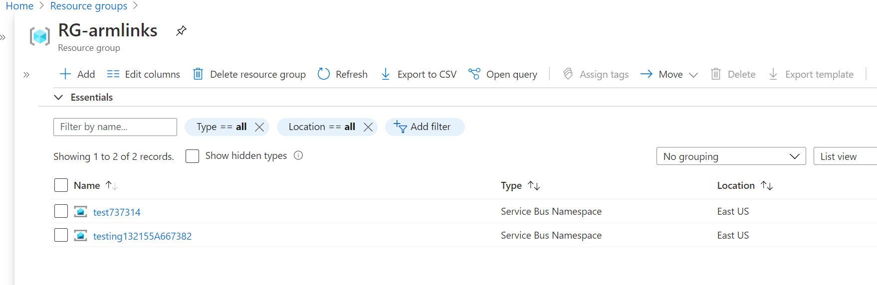

Test737314 is an existing namespace in that resource group, we deployed another namespace with name testing132155A667382 in incremental mode.

Created a different namespace with incremental mode again, nothing affected, a new namespace created!

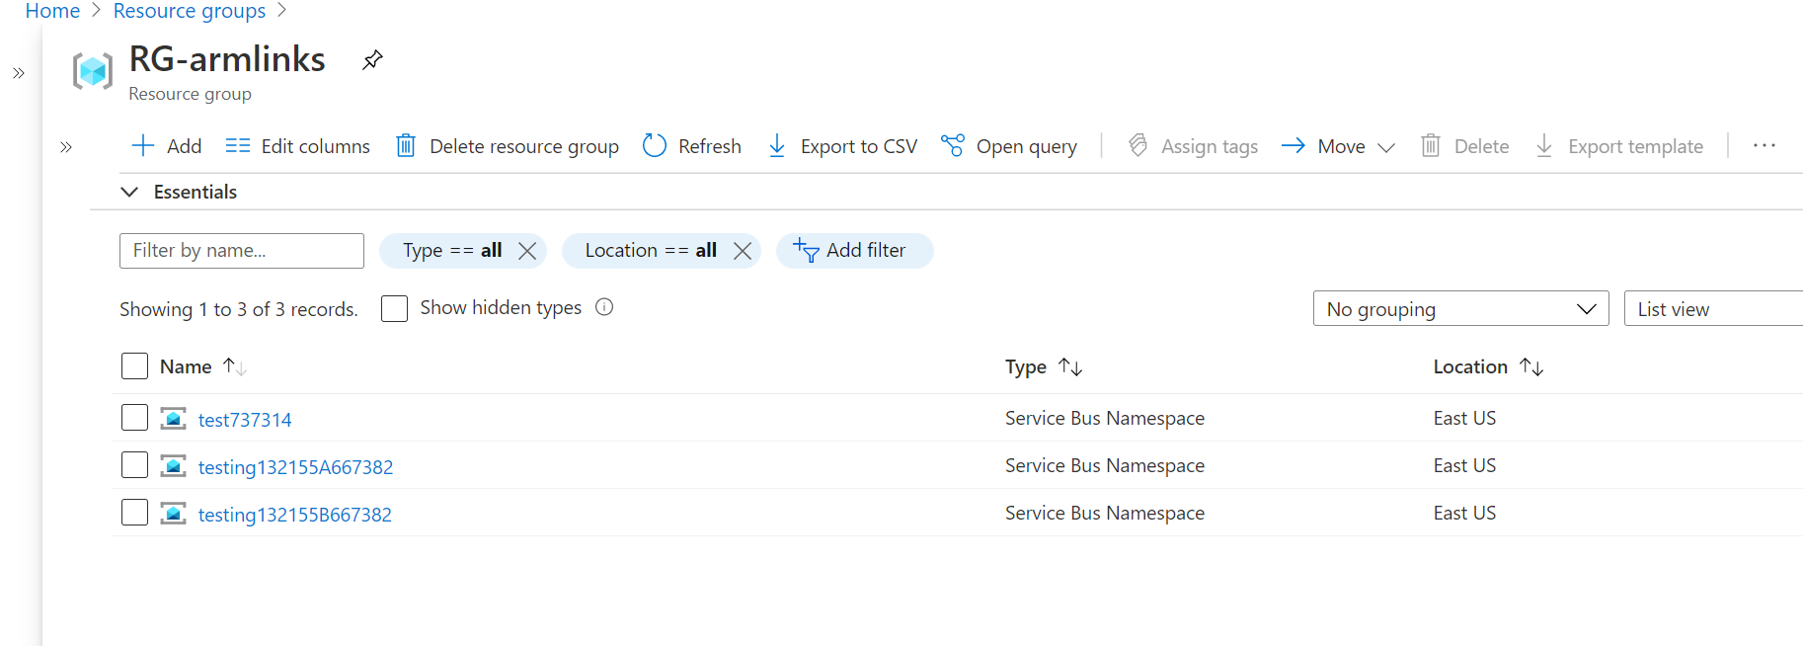

Now we will try with **Complete mode**  with the same ARM template and note down the observations

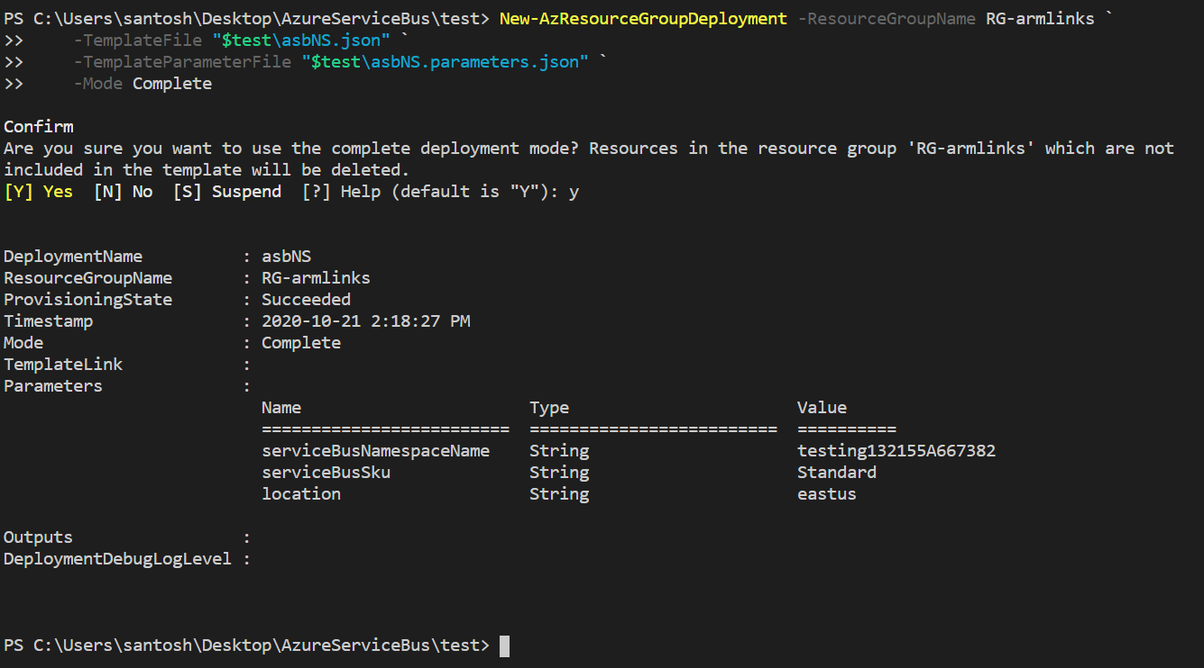

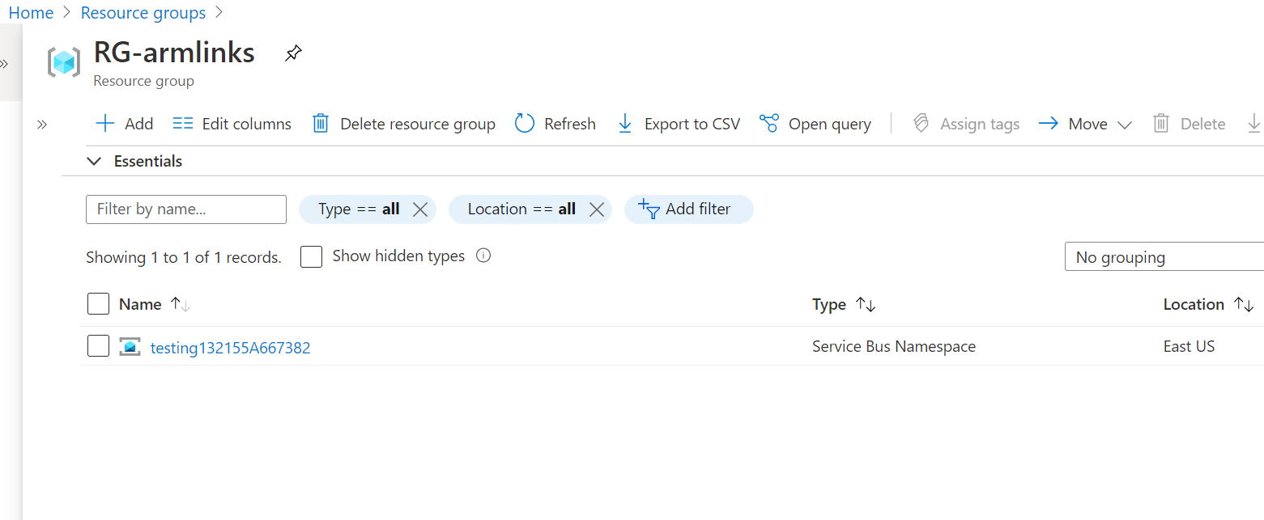

The resources which do not exist in the template got deleted and resources inside the template got deployed.

RollBack to previous deployment

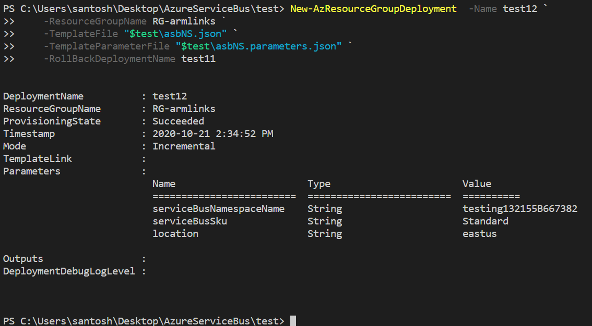

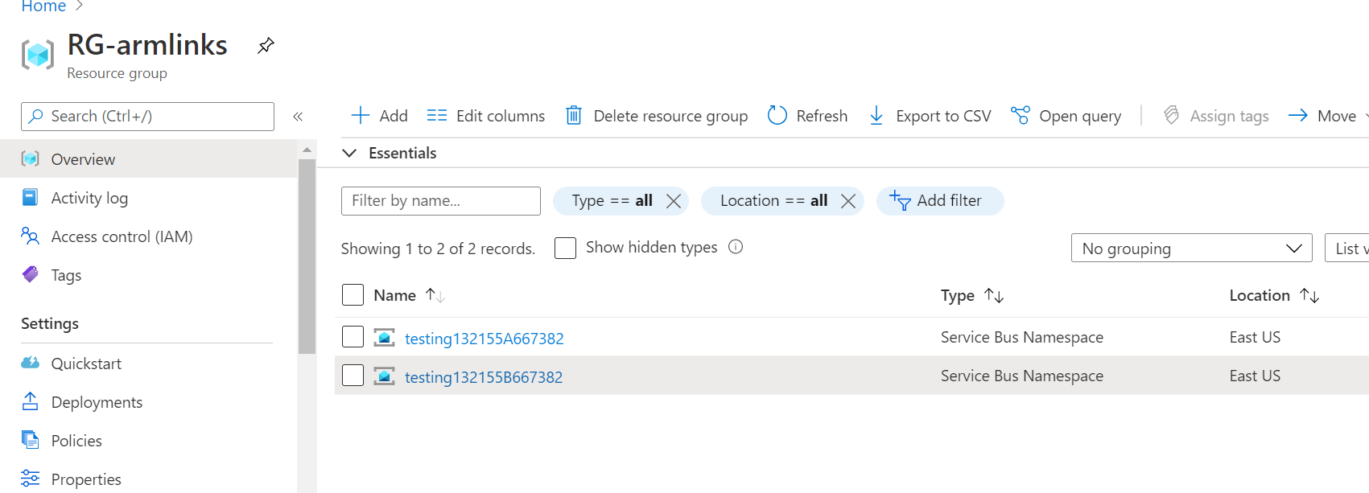

An ARM template deployed in incremental mode, which contains creation of a namespace and queues

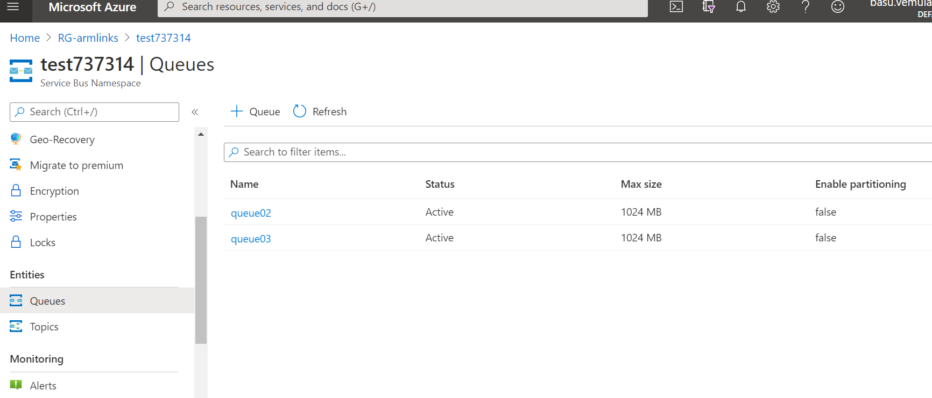

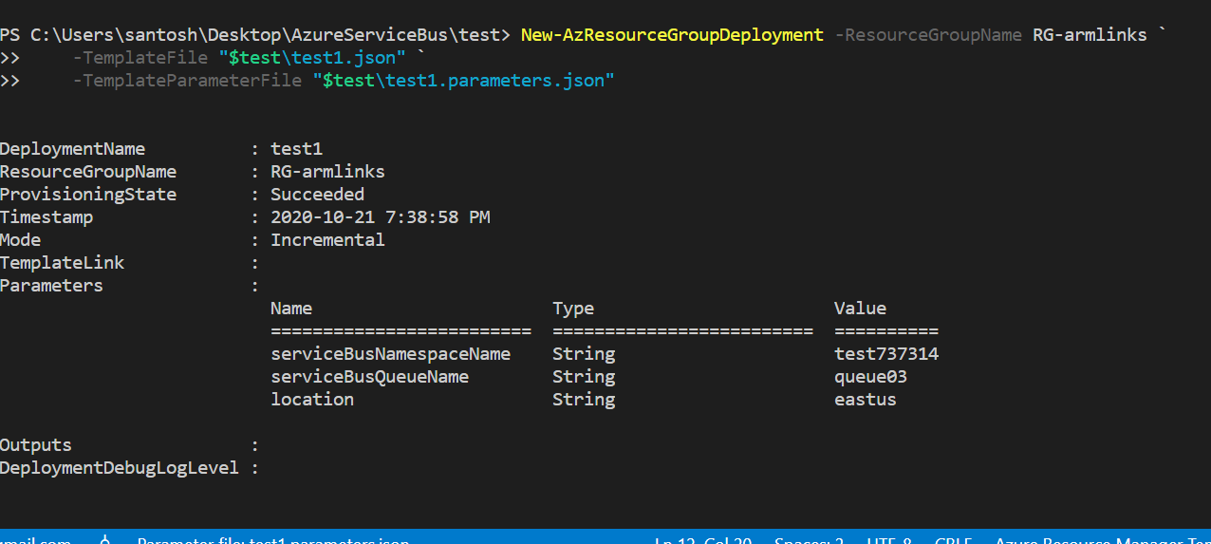

The same template deployed with different queue name (queue04) in **complete mode**

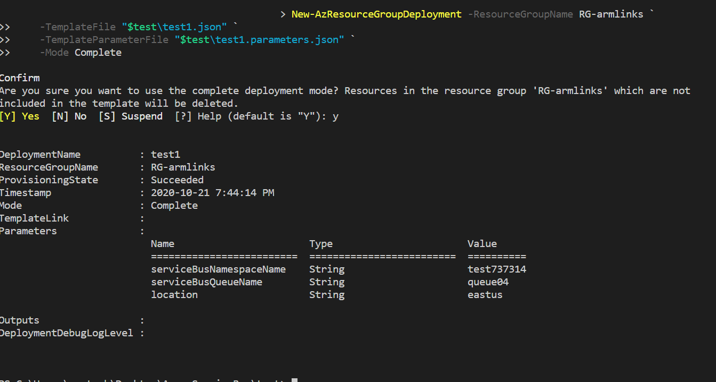

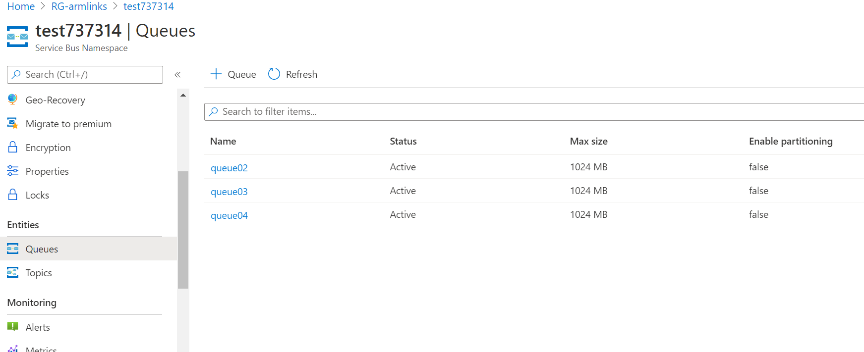

In this observation, as the queues are the child resources although queue02 and queue03 were not defined in the arm template they are still present in the namespace and not deleted!

**Observation on Parameters change:**

**INCREMENTAL MODE**

Successfully deployed an ARM template with highlighted properties

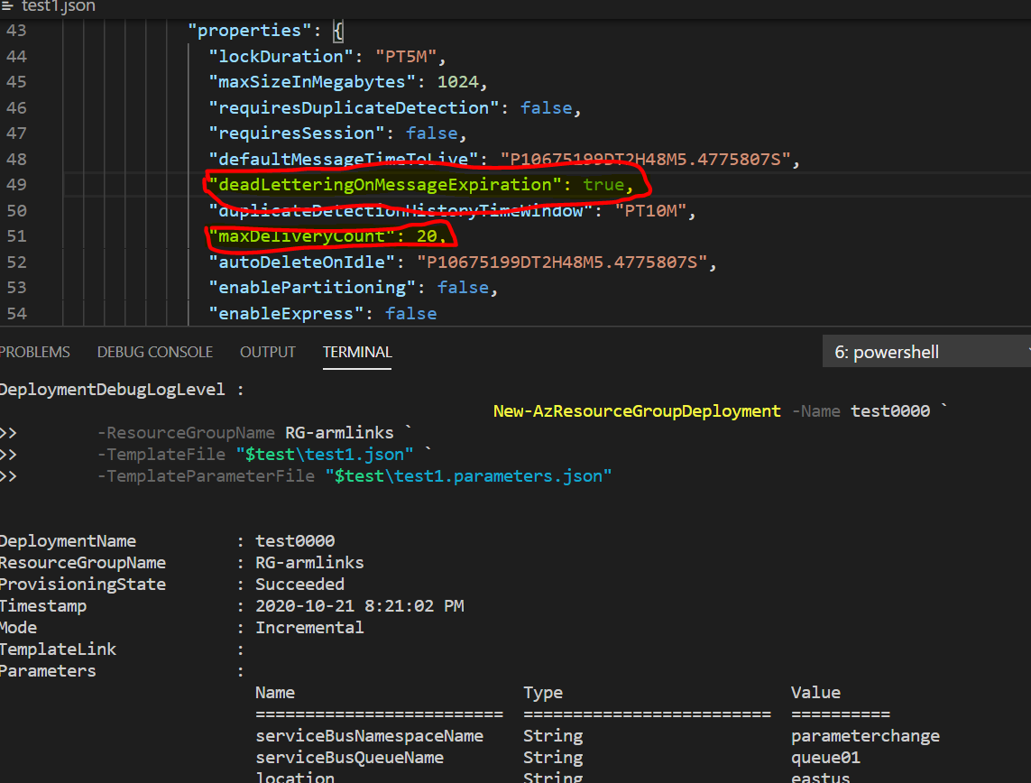

**We can clearly see deployed properties**

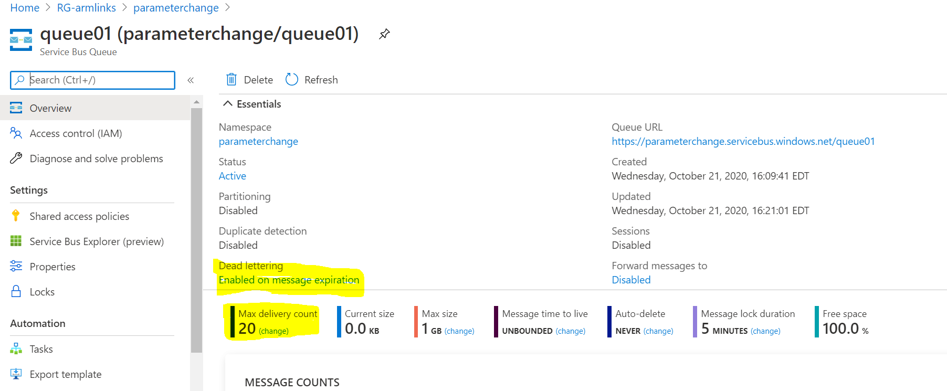

Rollback Scenario with the old properties defined in the ARM template

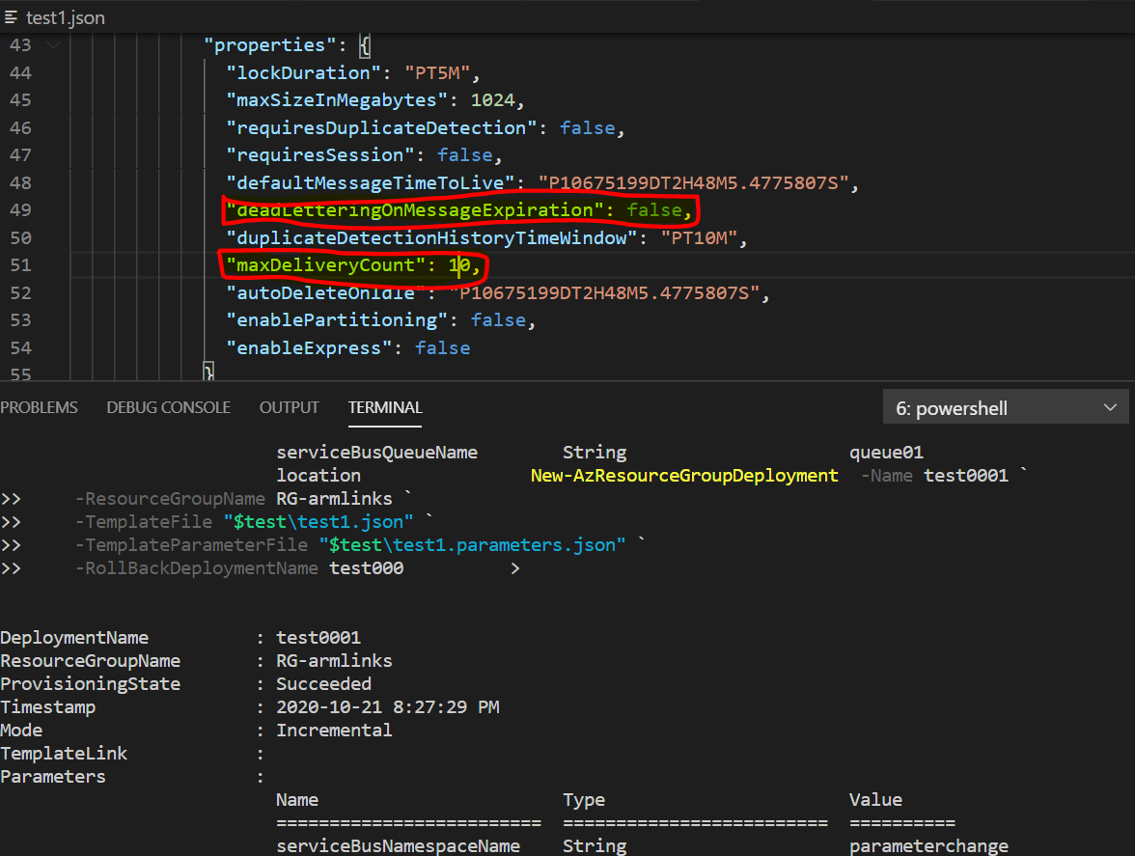

**In this observation we are able to deploy back to previous deployment state of the properties**

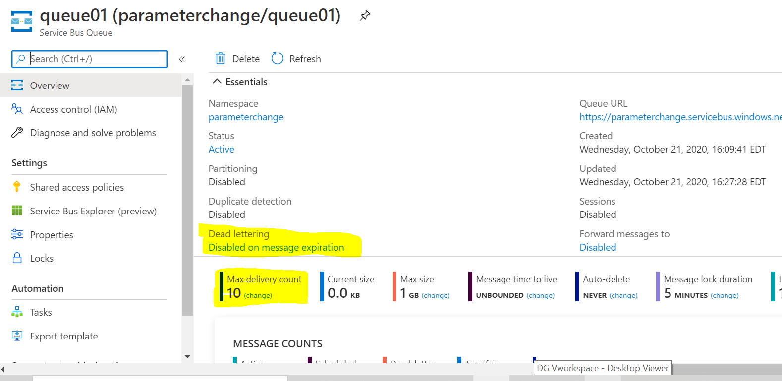

**COMPLETE MODE:**

**Deployed an ARM template in complete mode with default properties**

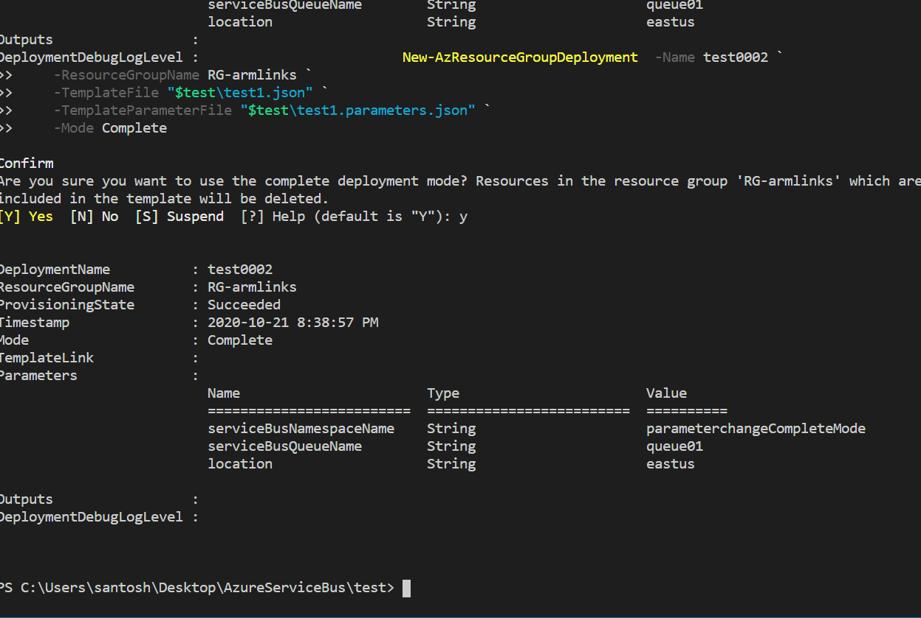

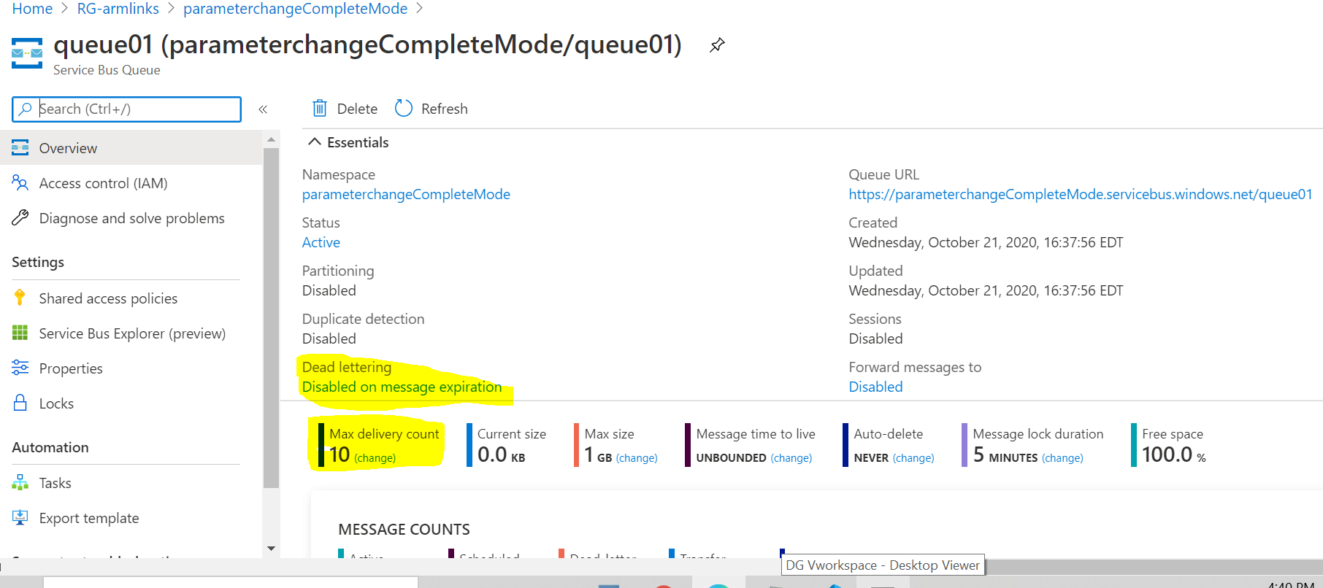

**Deployed same arm template in complete mode with 2 changes in properties**

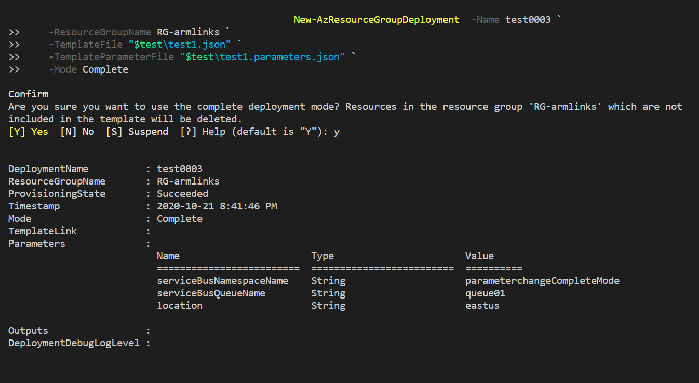

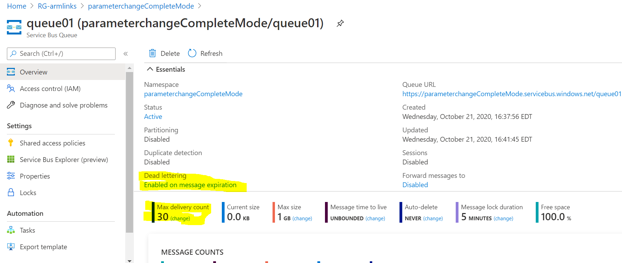

**ROLLBACK Scenario:**

**Now, In this Scenario, we are trying to roll back to previous deployment and we successfully deployed**

